Here’s a comprehensive digital marketing marketing startegy for haldiram:

\*Brand study\*:

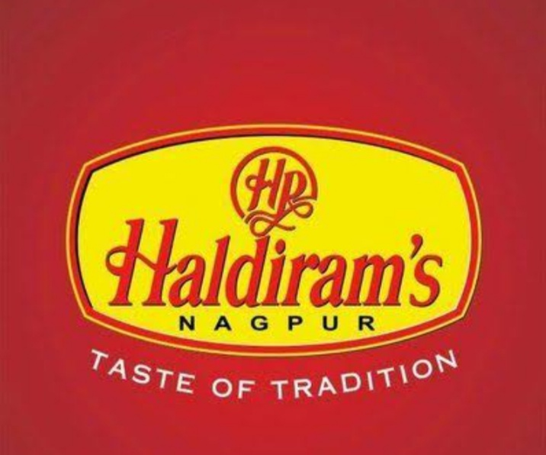

Haldiram's is a well-established Indian sweets and snacks brand with a rich history dating back to 1937. The brand is known for its high-quality products, traditional recipes, and iconic packaging.

\*Competitor Analysis\*:

Key competitors:

1. Bikanervala

2. MTR Foods

3. Britannia Industries

4. Parle Products

Competitor strength and weaknesses:

1.Bikanervala : Strong online presence, wide distribution network

Weakness: Limited product portfolio

2 .MTR Foods:Innovative products, strong brand recognition

Weakness: Limited online presence

3.Britannia industries : Strong brand recognition, wide distribution network

Weakness:Limited product portfolio in traditional sweets and snacks

4.parle products:Strong brand recognition, wide distribution network

Weakness: Limited product portfolio in traditional sweets and snacks

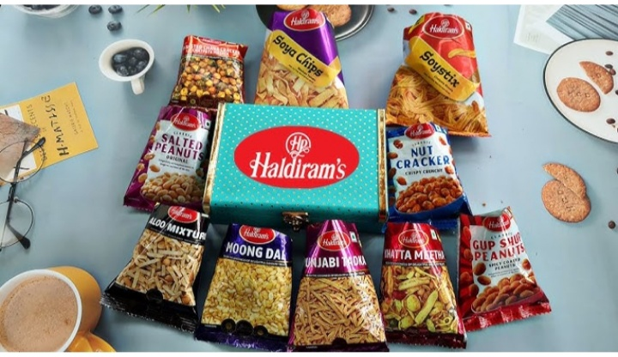

\*Buyer Audience persona Research\*

Target audience:

1.Demographics:Middle-aged individuals, families with young children

2.psychographics : Traditional, health-conscious, foodies

3. Pain points: Difficulty finding authentic, high-quality traditional sweets and snacks

4.Goals:To indulge in delicious, traditional sweets and snacks while maintaining a healthy lifestyle

5.preferred communication channels: Social media, email, online advertising

\*Digital Marketing strategy\*:

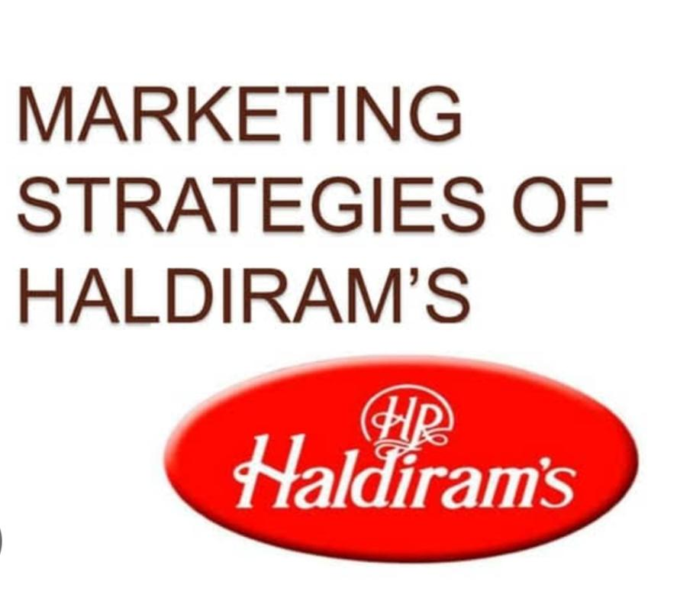

1.website\*: Revamp the existing website to provide a seamless user experience, easy navigation, and a comprehensive product catalog.

2.\*social media\*:

-Facebook: Share engaging content, promotions, and events to increase brand awareness and drive sales.

- Instagram:- Showcase products, share behind-the-scenes content, and collaborate with influencers to increase brand visibility.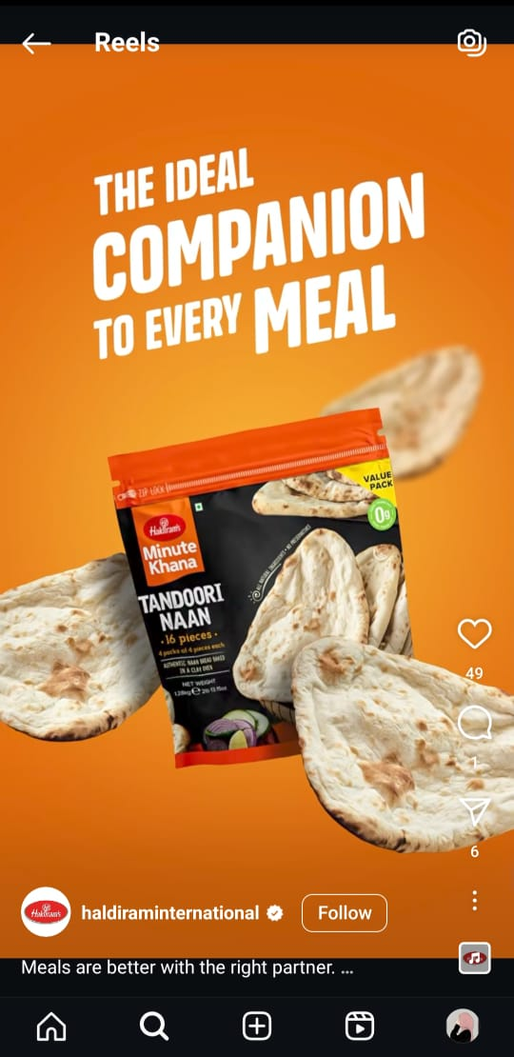

- Twitter: Share quick updates, promotions, and engage with customers to build brand loyalty.

3.Email Marketing: Send regular newsletters to subscribers showcasing new products, promotions, and events to drive sales and increase brand engagement.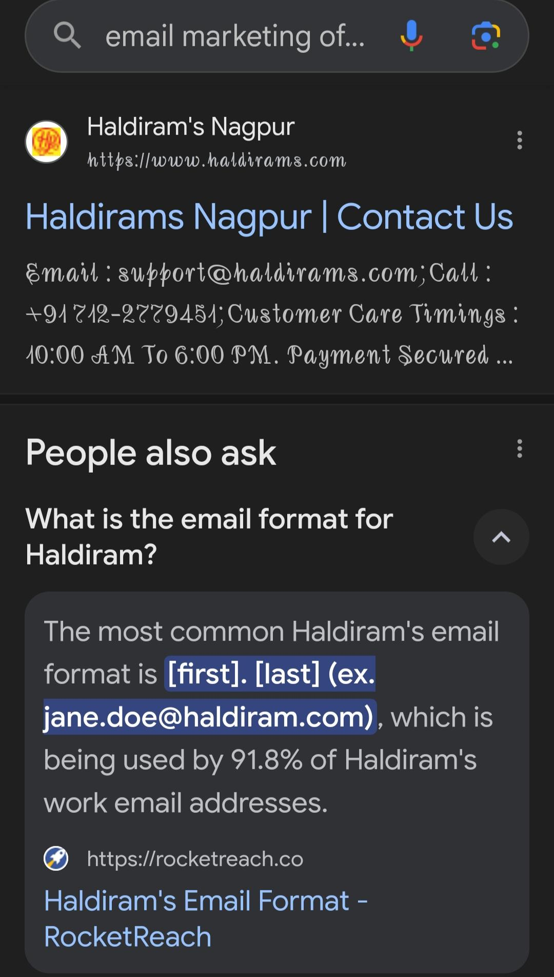

4.influencer Marketing:

Collaborate with social media influencers and bloggers in the food and beverage industry to promote Haldiram's products and increase brand visibility.

5.Content Marketing:

Create engaging content (blog posts, videos, infographics) showcasing traditional recipes, product benefits, and brand stories to increase brand awareness and drive sales.

6.paid Advertising

Run targeted online ads (Google Ads, Facebook Ads) to increase brand visibility, drive website traffic, and generate sales.

7.Search Engine optimisation (SEO) Optimize the website and online content to improve search engine rankings, increase website traffic, and drive sales.

Budget Allocation:

1. Website revamp: 20%

2. Social media marketing: 25%

3. Email marketing: 10%

4. Influencer marketing: 15%

5. Content marketing: 10%

6. Paid advertising: 20%

Timeline:

Quarter 1 (January-March): Website revamp, social media setup, and content creation

Quarter 2 (April-June): Launch influencer marketing campaign, email marketing campaign, and paid advertising

Quarter 3 (July-September): Analyze results, optimize campaigns, and plan for festive season promotions

Quarter 4 (October-December): Execute festive season promotions, launch new products, and review year-end performance

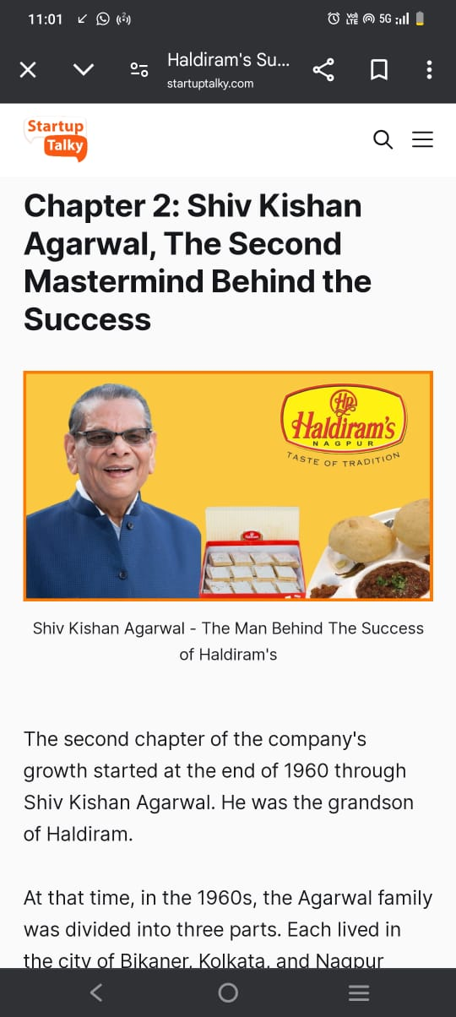

Haldiram ‘s Background

1.History: Haldiram's was founded in 1937 by Ganga Ram Agrawal.

2. Product: Haldiram's offers a wide range of traditional Indian sweets, snacks, and beverages.

3.Target Audience: Haldiram's targets Indian families, youngsters, and individuals who crave traditional Indian sweets and snacks.

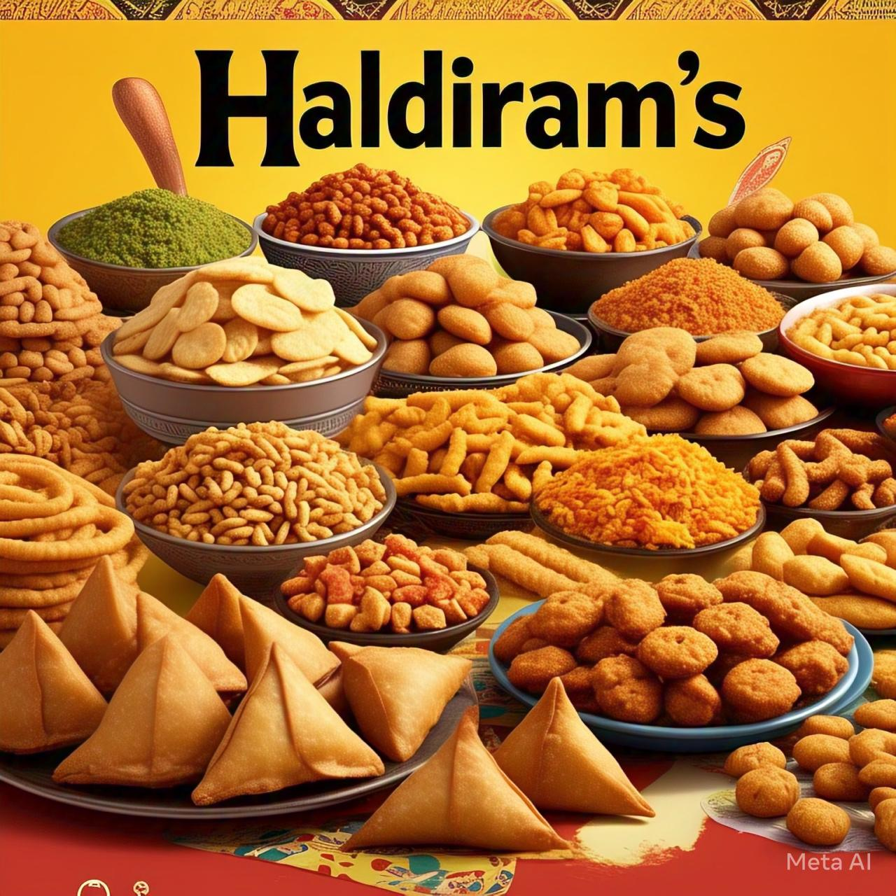

Digital marketing objectives

1.increase Brand Awareness

Create awareness about Haldiram's brand, products, and services.

2.Drive website Traffic: Increase website traffic and encourage online ordering.

3.Boost sales: Boost sales through online and offline channels.

4.Engage with Customer: Engage with customers through social media, email marketing, and loyalty programs.

Digital marketing startegies

1.social media marketing:

Leverage Facebook, Instagram, Twitter, and YouTube to share engaging content, promotions, and events.

2.content Marketing:

Create informative blog posts, videos, and guides that showcase Haldiram's products, recipes, and cooking tips.

3.Email Marketing : Build an email list and send regular newsletters, promotions, and offers to subscribers.

4.influencer Marketing:

Partner with food influencers, bloggers, and celebrities to promote Haldiram's products.

5.paid Advertising :

Run targeted Google Ads, Facebook Ads, and Instagram Ads to reach potential customers.

6.Search engine optimisation (SEO)

Haldiram's website for search engines to improve visibility and drive organic traffic.

Content creation:

1.Product Description:

Write detailed and mouth-watering product descriptions for Haldiram's website.

2.Recipes: Create and share recipes that feature Haldiram's products.

3.Blog posts: Write informative blog posts about Indian sweets, snacks, and beverages.

4.videos : Produce high-quality videos that showcase Haldiram's products, cooking processes, and customer testimonials.

Social media content calender:\*

1.Facebook: Share promotional posts, events, and updates.

2.Instagram: Share visually appealing images and videos of Haldiram's products.

3.Twitter: Share quick updates, promotions, and engage with customers.

4.You Tube

Share recipe videos, product reviews, and customer testimonials.

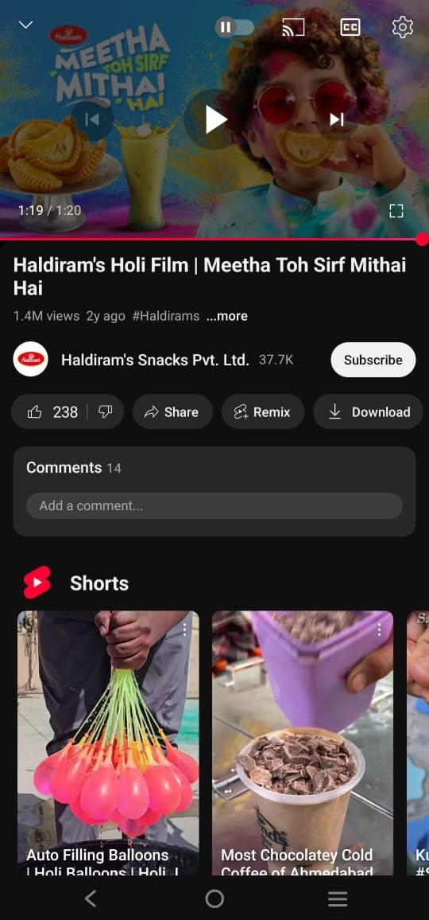

E-mail marketing campaigns

1.welcome Email: Send a welcome email to new subscribers with exclusive offers and discounts

.

2.Promotional E-mails : Send regular promotional emails with new product launches, offers, and discounts.

3.Abandoned cart E-mails; Send reminders to customers who have abandoned their shopping carts.

Influencer marketing partnership

1. \*Food Influencers\*: Partner with food influencers to promote Haldiram's products.

2. \*Bloggers\*: Partner with bloggers to review and promote Haldiram's products.

3. \*Celebrities\*: Partner with celebrities to endorse Haldiram's products.

Budget Allocation:

1.Social Media:

Allocate 30% of the budget to social media marketing.

2.Content Creation:

Allocate 20% of the budget to content creation.

3.Influencer Marketing:

Allocate 15% of the budget to influencer marketing.

4.Paid Advertising:

Allocate 25% of the budget to paid advertising.

5.Email Marketing:

Allocate 10% of the budget to email marketing.

Digital marketing strategy



1.social Media marketing:Creating and implementing a social media strategy to increase brand awareness, engagement, and sales

.

2.Email Marketing: Building and sending targeted email campaigns to subscribers to promote products, offers, and events.

3.Influencer Marketing: Partnering with influencers to promote Haldiram's products to their followers.

4.Content Marketing :Creating and distributing valuable, relevant, and consistent content to attract and retain a clearly defined audience

5.Paid Advertising :Running paid ads on Google, Facebook, Instagram, and other platforms to reach a wider audience.

Content creation

1.Blog posts : Writing informative and engaging articles about Haldiram's products, recipes, and Indian cuisine.

2.social media posts: Creating and scheduling social media posts, including images, videos, and captions.

3.Email Newsletters: Designing and sending regular newsletters to subscribers showcasing Haldiram's products, offers, and events.

4.Video content: Producing high-quality video content, such as recipe videos, product reviews, and behind-the-scenes stories.

5.infographics: Creating visually appealing infographics highlighting Haldiram's products, recipes, and nutritional information.

Haldiram - specific Topics :

1.product showcases:Highlighting Haldiram's products, including images, descriptions, and nutritional information.

2.Recipe content: Creating and sharing recipes that feature Haldiram's products.

3.Behind -the-Scenes: Sharing stories about Haldiram's history, manufacturing process, and employees.

4.Cuetomer Testimonial:Sharing customer reviews, ratings, and testimonials about Haldiram's products.

5.Brand History and legacy:Sharing Haldiram's rich history, legacy, and cultural significance.

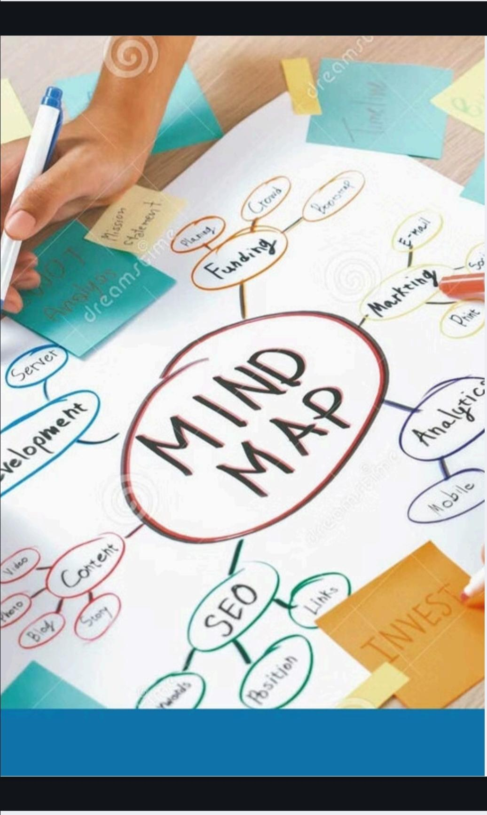

Technical and Analytics

1.website optimization: Ensuring Haldiram's website is user-friendly, fast, and optimized for search engines.

2.SEO: Improving Haldiram's website's search engine ranking through keyword research, on-page optimization, and link building.

3.Google Analytics : Tracking and analyzing website traffic, engagement, and conversion rates.

4.Social Media Analytics: Monitoring and analyzing social media performance, including engagement rates, reach, and clicks.

5.Email Marketing Metrics: Tracking and analyzing email marketing performance, including open rates, click-through rates, and conversion rates

Search Engine optimization (SEO)

\*What is SEO?\*

SEO is the process of improving the visibility and ranking of a website in search engine results pages (SERPs) through various techniques and strategies.

Types of SEO \*

1. \*On-Page SEO\*: Optimizing website elements like title tags, meta descriptions, headings, content, and internal linking.

2. \*Off-Page SEO\*: Building high-quality backlinks from other websites, social media, and local directories.

3. \*Technical SEO\*: Optimizing website structure, speed, mobile responsiveness, and XML sitemaps.

SEO BEST PRACTICES:



1. \*Keyword Research\*: Identify relevant keywords and phrases.

2. \*High-Quality Content\*: Create engaging, informative, and unique content.

3. \*Optimize Images\*: Use descriptive alt tags and file names

.

4. \*Internal Linking\*: Link to relevant pages on your website.

5. \*Mobile-Friendliness\*: Ensure a smooth user experience on mobile devices.

6. \*Page Speed\*: Aim for a load time of under 3 seconds.

7. \*Local SEO\*: Optimize for local search by including name, address, and phone number (NAP) consistently.

SEO TOOLS \*

1. Google Analytics

2. Google Search Console

3. Ahrefs

4. SEMrush

5. Moz

\*Why is SEO important ?

1. \*Increased Visibility\*: Appear in search engine results pages (SERPs).

2. \*Targeted Traffic\*: Attract relevant and high-quality website visitors.

3. \*Cost-Effective\*: Long-term results with minimal investment.

4. \*Brand Credibility\*: Establish your brand as an authority in your industry.

Brand marketing strategy for haldiram: 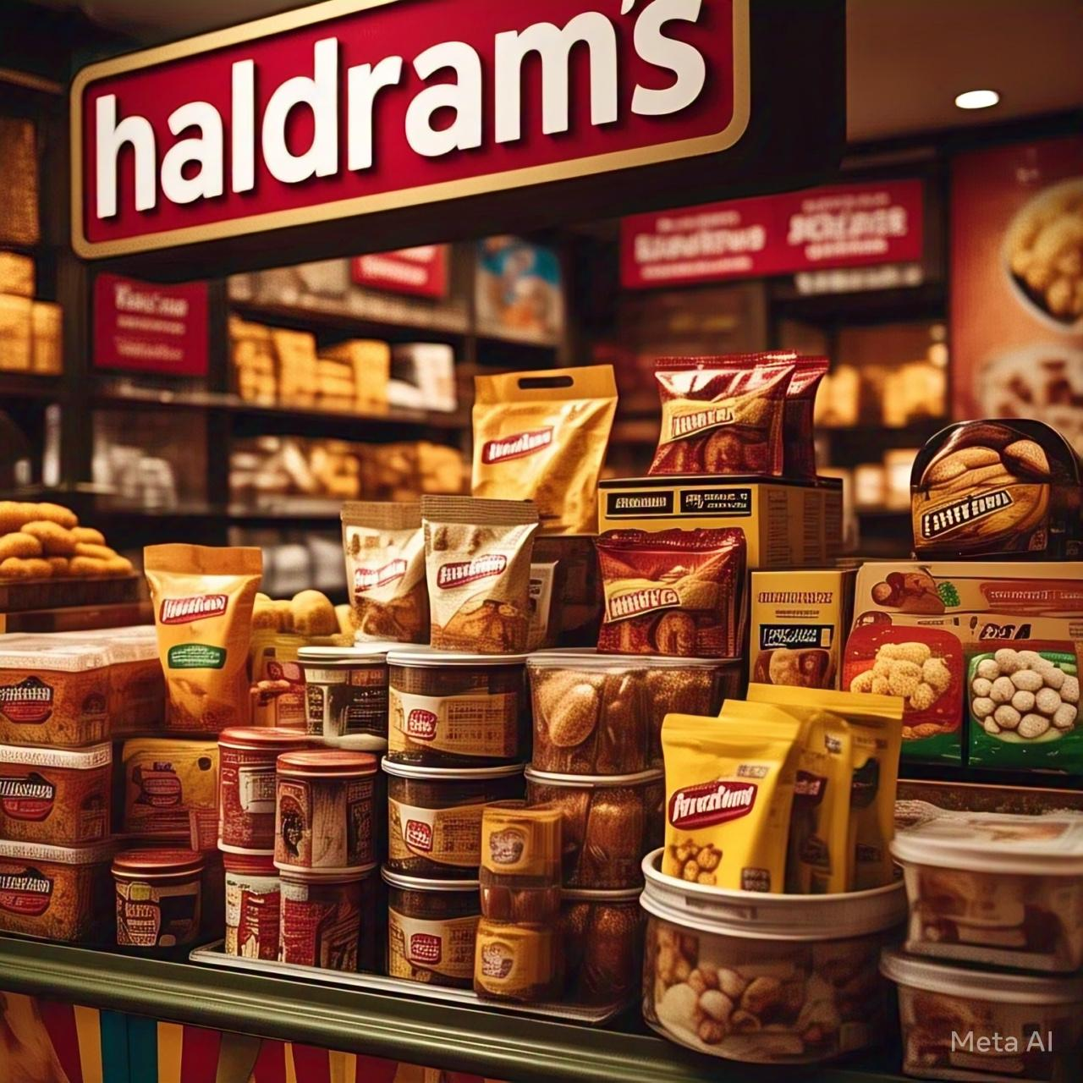

Brand positioning

Haldiram positions itself as a trusted and iconic Indian snack food brand, offering a wide range of traditional and modern products that cater to diverse consumer preferences.

Target A udience

1.Demographics : Middle-class and upper-middle-class individuals, families, and young professionals.

2.Psychographics: People seeking authentic Indian taste, quality, and convenience.

Marketing Objectives

1. Increase brand awareness and recognition.

2. Drive sales growth and market share expansion.

3. Enhance customer engagement and loyalty.

Marketing strategies

\*1.product strategy\*

1.product portfolio: Offer a diverse range of snacks, sweets, and beverages.

2.innovations: Introduce new and unique products, such as flavored namkeens and fusion sweets.

3.Quality Focus : Maintain high-quality standards, ensuring freshness and taste.

\*2.pricing strategy\*

1.Competitive pricing : Set prices competitively, balancing profitability and customer affordability.

2. Premium products: Offer premium products at higher price points to cater to discerning customers.

\*3.promotion strategy\*:

1.Advertising: Utilize television, print, digital, and outdoor media for brand promotion.

2.Social media: Leverage platforms like Instagram, Facebook, and Twitter for engagement and influencer partnerships.

3.Events and sponsorships: Participate in food festivals, sponsor events, and collaborate with celebrities.

\*4 Place strategy ( Distribution)

1.Wide distribution Network: Establish a strong presence in retail stores, supermarkets, and online marketplaces.

2. E- commerce platform: Develop a user-friendly website and mobile app for online sales.

5.Digital Marketing\*:

1.Search Engine optimization (SEO ) Optimize the website for search engines to improve visibility.

2.Content Marketing Create engaging content (blog posts, videos, recipes) to attract and retain customers.

3. Email Marketing : Send regular newsletters and offers to subscribers.

\*6 Customer Relationship Management CRM \*

1.loyalty program: Implement a loyalty program to reward repeat customers.

2.Customer Feedback : Collect feedback through surveys, social media, and customer support channels.

Performance Metrics :

1. Sales growth

2. Market share

3. Customer acquisition and retention rates

4. Social media engagement metrics (likes, shares, comments)

5. Website traffic and online sales

By implementing this comprehensive marketing strategy, Haldiram can reinforce its brand position, drive business growth, and maintain its leadership in the Indian snack food market

Content creation and SEO strategy for haldiram;

Content creation strategy

\*1.Blog posts\*:

1.Recipe Blog posts; Share traditional Indian recipes featuring Haldiram products.

2.Food Blog posts; Write about Indian cuisine, food trends, and cultural significance.

3.Lifestyle Blog posts: Create content around health, wellness, and entertainment.

2.social Media content\*:

1.Product showcase: Share high-quality product images and videos.

2.Behind -the- sciences: Give sneak peeks into Haldiram's manufacturing process, events, and company culture.

3User- Generated content: Encourage customers to share photos or videos of them enjoying Haldiram products.

3 video content

1.Recipe videos: Create step-by-step recipe videos featuring Haldiram products.

2.product Review videos:Showcase product features, benefits, and customer testimonials.

3.Brand story videos: Share Haldiram's history, mission, and values.

4 influencer content

1.partnerships:Collaborate with social media influencers, food bloggers, and Indian cuisine experts

2.Sponsored content : Partner with influencers to create sponsored content featuring Haldiram products.

SEO strategy

\*1.keyword Research:

1.identify Relevant keywords Conduct thorough keyword research to identify relevant terms, such as "Indian snacks," "namkeen," and "traditional sweets."

2.long -tail keywords: Target long-tail keywords, like "Haldiram namkeen recipes" or "best Indian snack brands."

2 On - page optimization:

1. Title tags; Write descriptive, keyword-rich title tags for each webpage.
2. Meta Descriptions: Craft compelling, informative meta descriptions to entice users to click.

3 Header tags: Organize content using header tags (H1, H2, H3, etc.).

3 content optimization

1.keyword integration: Naturally incorporate target keywords into content.

2. Content quality:Focus on creating high-quality, engaging, and informative content.

3.content length: Ensure content is comprehensive and detailed, but also concise and scannable.

\*4.Technical SEO\*

1.page speed: Ensure fast page loading speeds (less than 3 seconds)

2.Mobile -friendliness: Ensure a seamless user experience across mobile devices.

1. XML sitemap: Create and submit a comprehensive XML sitemap to Google.

\*5Link Building: \*

1.Guest Blogging: Write guest posts for relevant food, lifestyle, and Indian culture blogs.

2.product Reviews: Reach out to influencers and bloggers for product reviews.

3.Partnership: Collaborate with other Indian food brands, restaurants, or food delivery services.

\*6.local SEO\* \*

1.Google my business : Claim and optimize Haldiram's Google My Business listing.

2.Local citations: Ensure consistent NAP (name, address, phone number) across local directories.

3.Location -specific content ;

Create content highlighting Haldiram's presence in specific cities or regions.

Performance Metrics:

1. Website traffic

2. Search engine rankings (SERPs)

3. Social media engagement metrics (likes, shares, comments)

4. Conversion rates (sales, leads, etc.)

5. Keyword rankings and impressions

By implementing this comprehensive content creation and SEO strategy, Haldiram can:

1. Enhance its online presence and visibility.

2. Drive more website traffic and sales.

3. Establish itself as a thought leader in the Indian snack food industry.

4. Improve its search engine rankings and keyword visibility.

Some content creation for Haldiram ;

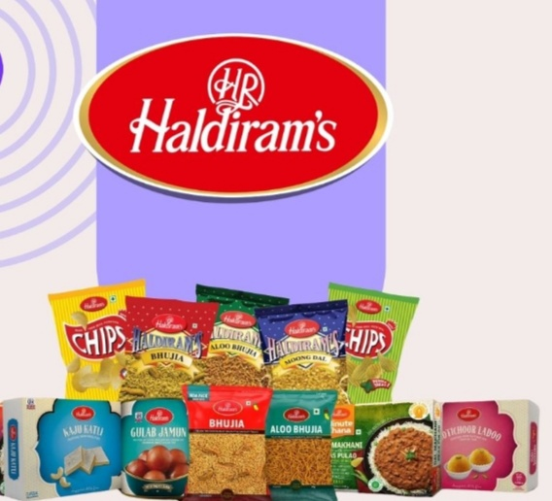

Recipe - based content:

1.Trqditional Indian Recipes: Share recipes that feature Haldiram products, such as namkeen, sweets, or snacks.

2.Fusion Recipes: Create modern twists on traditional Indian recipes using Haldiram products.

3.Recipe videos : Produce step-by-step recipe videos featuring Haldiram products.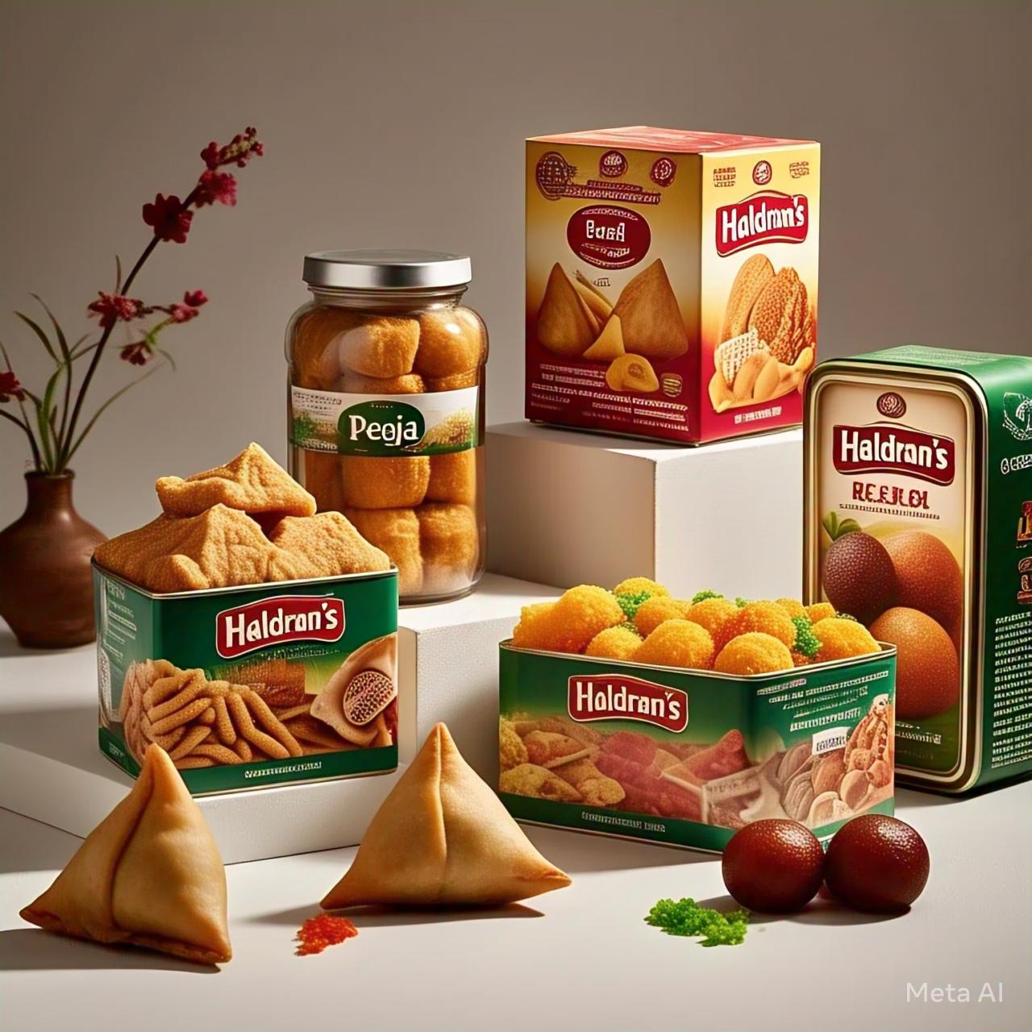

Cultural and Heritage - based content

1.indian festival Recipes: Share traditional recipes and stories behind Indian festivals, such as Diwali, Holi, or Navratri.

2.Regional indian cuisine: Highlight the diversity of Indian cuisine by featuring recipes and stories from different regions.

3.indian Food culture:Create content that showcases the significance of food in Indian culture, such as the importance of sharing meals with family and friends.



Lifestyle and wellness -based content

1.Healthy snacking Options: Share tips and recipes for healthy snacking using Haldiram products.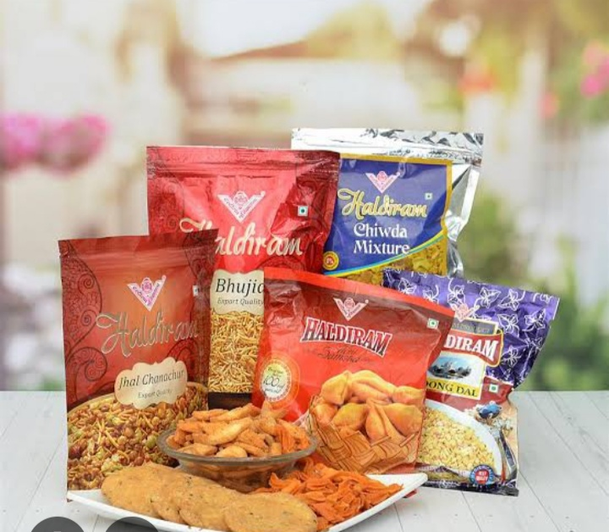

2.wellness and nutrition: Create content that highlights the nutritional benefits of Haldiram products, such as the importance of fiber, protein, or healthy fats.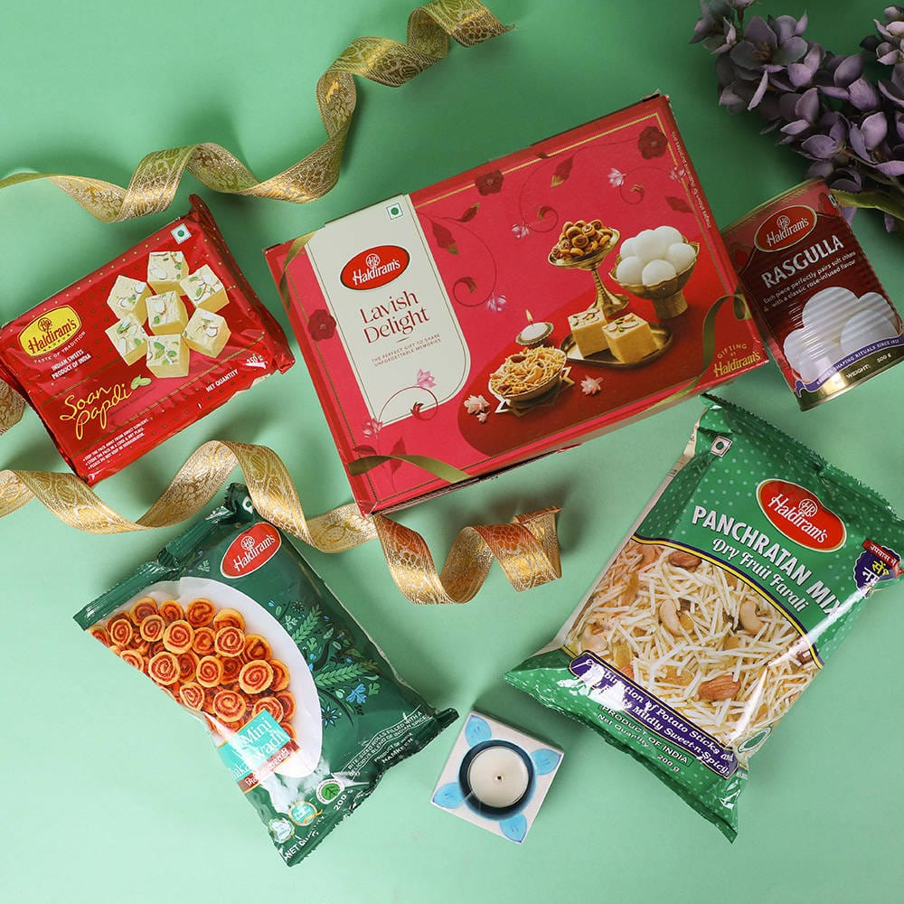

3.Mindful Eating: Produce content that promotes mindful eating and the importance of savoring each bite.

User - generated content campaign

1.share your haldiram moment:

Encourage customers to share photos or videos of them enjoying Haldiram products.

2. Haldiram Recipe contest: Host a recipe contest where customers can submit their own recipes using Haldiram products.

3.Haldiram foodie challenge:

Create a social media challenge that encourages customers to try new Haldiram products and share their experiences.

Behind -the-scenes content

1.Factory Tour:Give customers a sneak peek into Haldiram's manufacturing process.

2.Meet the chef: Introduce customers to Haldiram's chefs and share their stories and recipes.

3. Product Development: Share the story behind the development of new Haldiram products.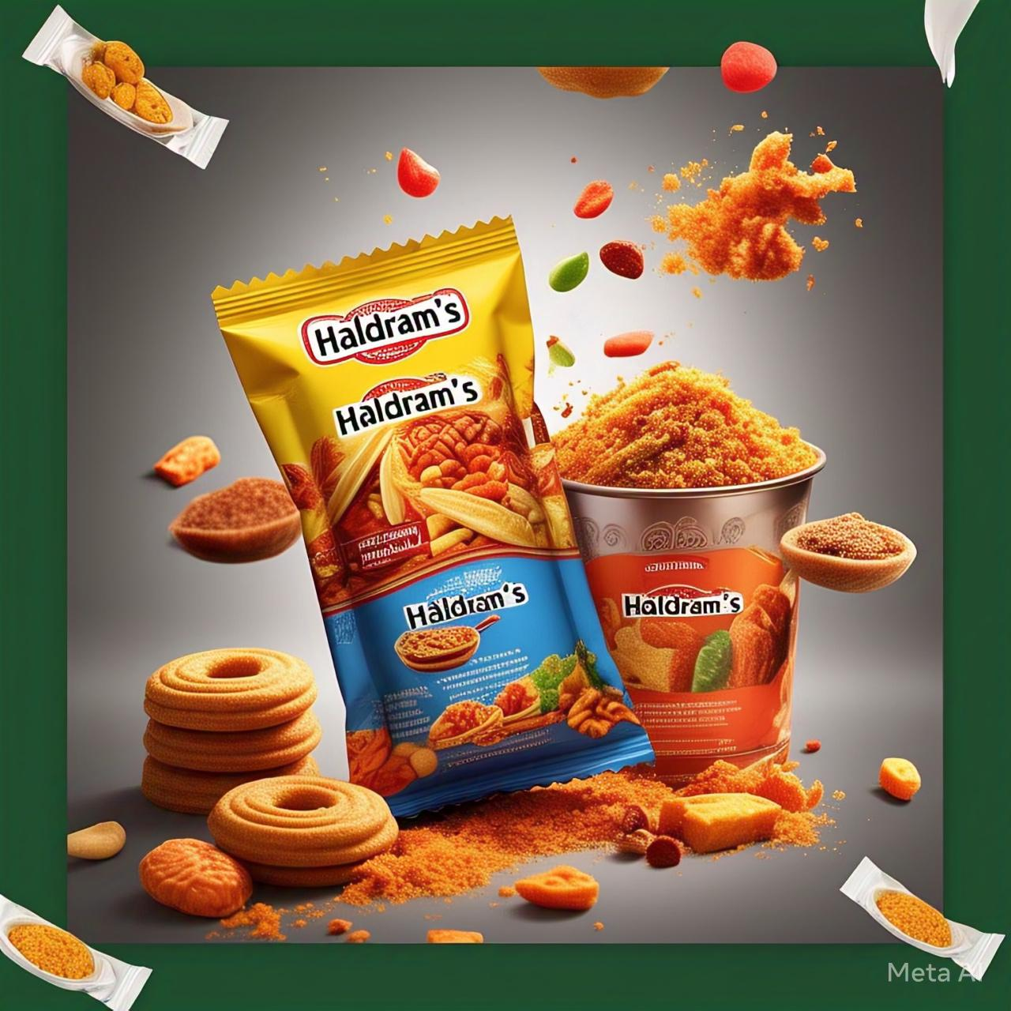

Seasonal and timely content

1.summer snacking Tips: Share tips and recipes for healthy snacking during the summer months.

2. Winter comfort food: Create content that highlights the comfort food aspect of Haldiram products during the winter months.

3 Holiday Recipes:Share traditional recipes and stories behind Indian holidays, such as Diwali or Holi.

Influencer and partnership content

1.influencer partnership: Collaborate with social media influencers, food bloggers, or Indian cuisine experts to promote Haldiram products.

2.Chef partnership: Partner with renowned chefs to create exclusive recipes using Haldiram products.

3.Brand partnership: Collaborate with other Indian food brands or restaurants to create content and promote each other's products.

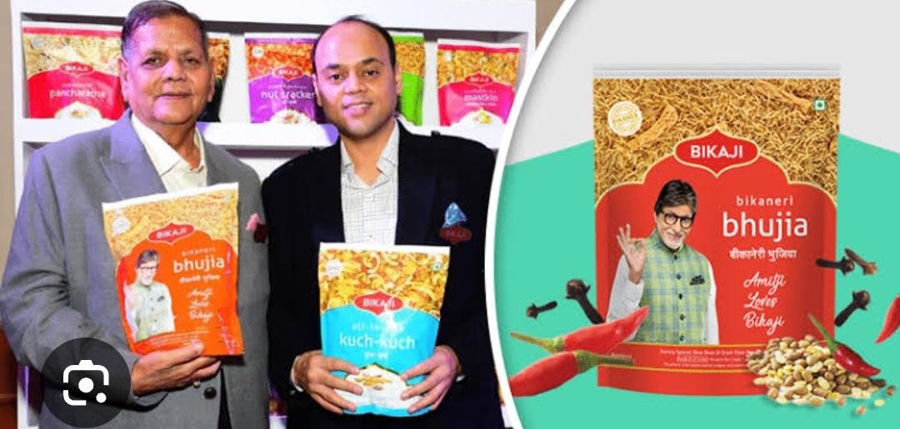

These content ideas will help Haldiram connect with its audience, showcase its products, and establish itself as a thought leader in the Indian snack food industry.

Content curation strategy for haldiram:

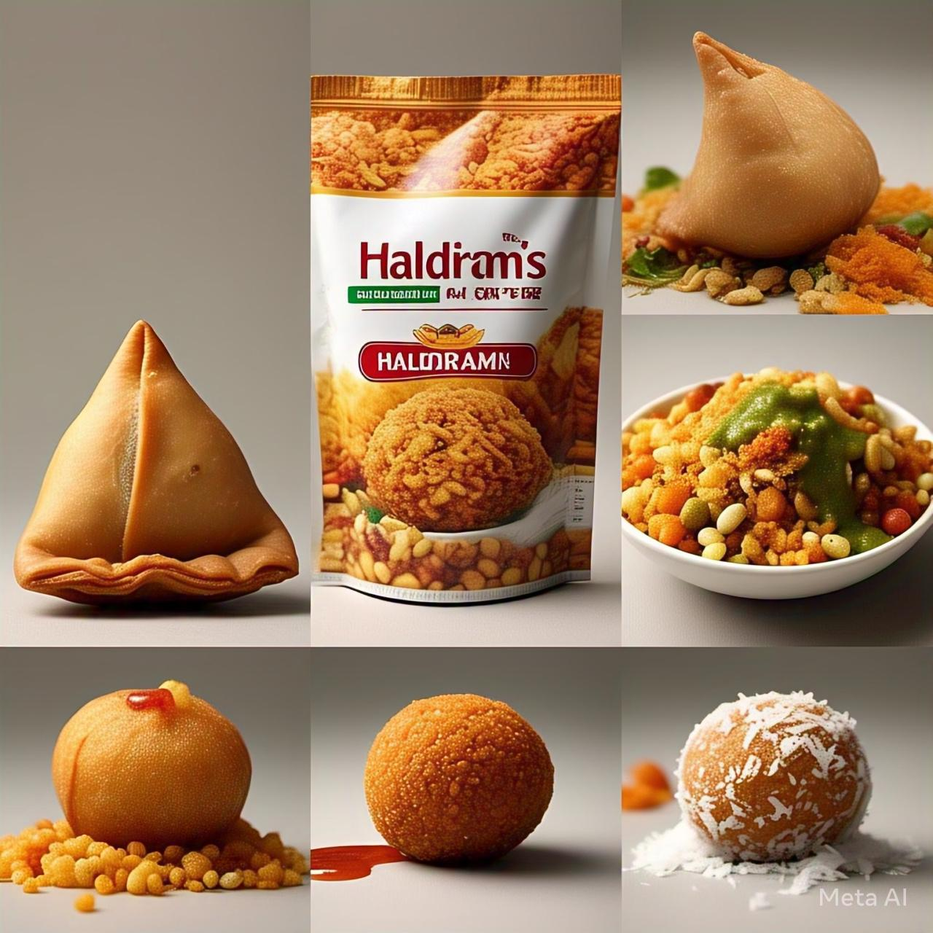

Content types

1.Recipes: Curate traditional Indian recipes, modern twists, and fusion recipes that feature Haldiram products

.

2.Food stories: Share stories behind Indian cuisine, regional specialties, and the cultural significance of food in Indian culture

.

3.Lifestyle and wellness: Curate content on healthy eating, mindful eating, and wellness tips that incorporate Haldiram products.

4.product showcase: Highlight Haldiram products through high-quality images, videos, and product reviews.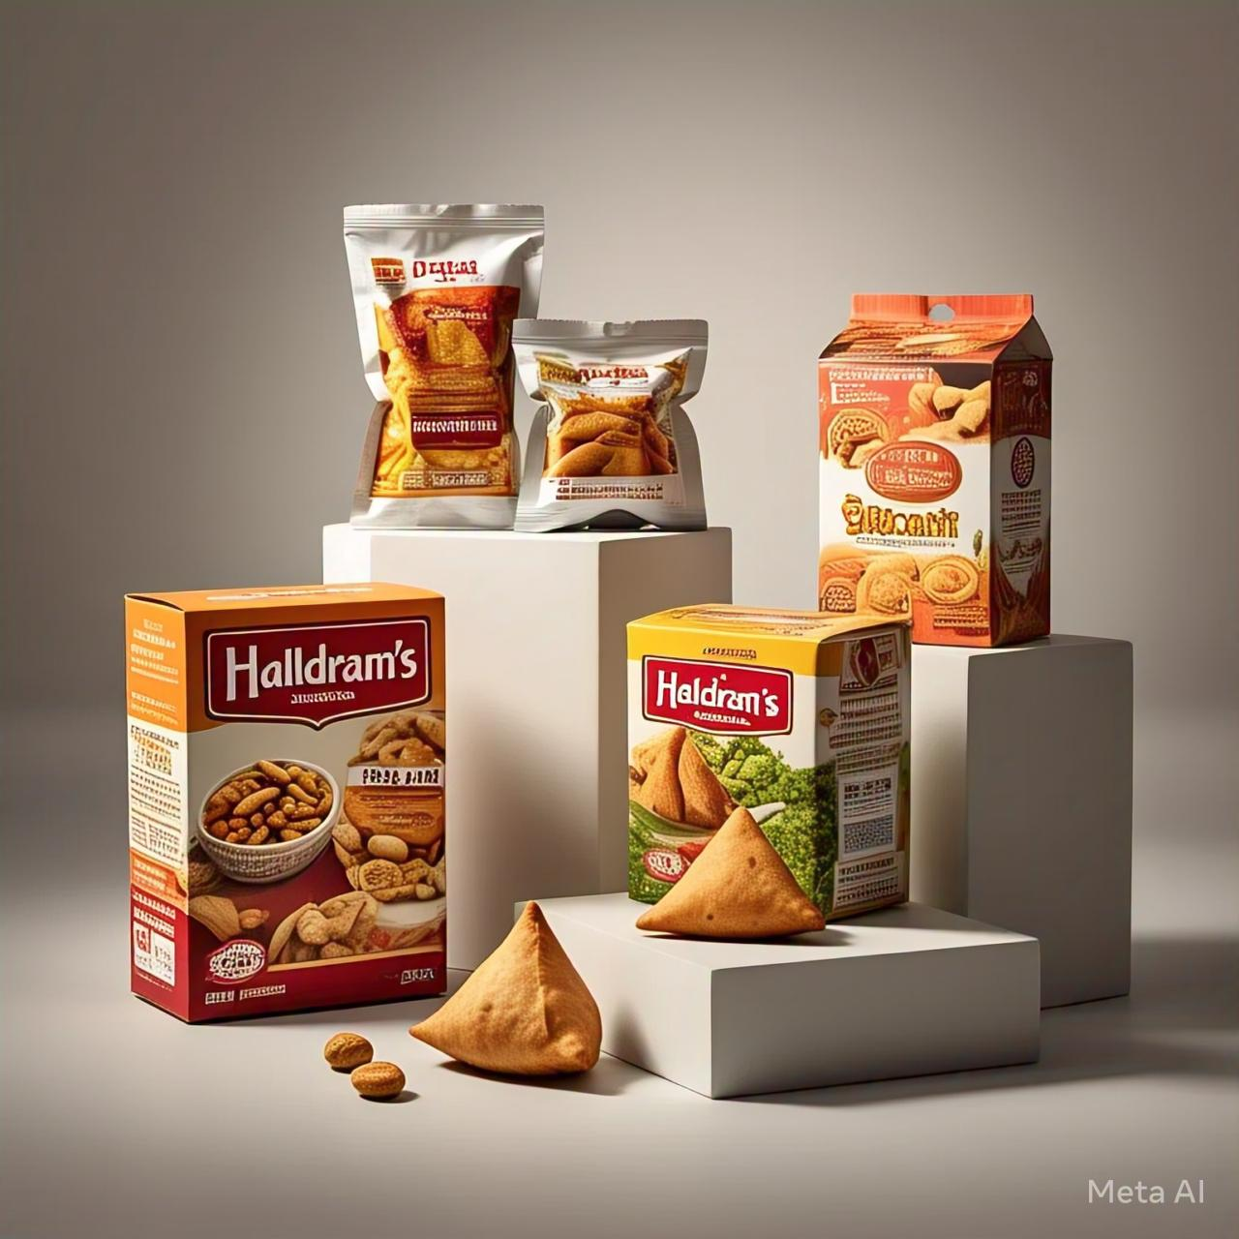

5.User -generated content: Encourage customers to share their experiences, photos, and videos of enjoying Haldiram products.

Content sources

1.Haldiram website: Utilize existing content from Haldiram's website, such as recipes, product information, and company news.

2.Social Media: Curate content from Haldiram's social media channels, including Instagram, Facebook, Twitter, and YouTube

.

3.Food Blogs : Partner with Indian food bloggers to curate recipes, stories, and product reviews.

4.influencer content: Collaborate with social media influencers, food experts, and Indian cuisine enthusiasts to curate content.

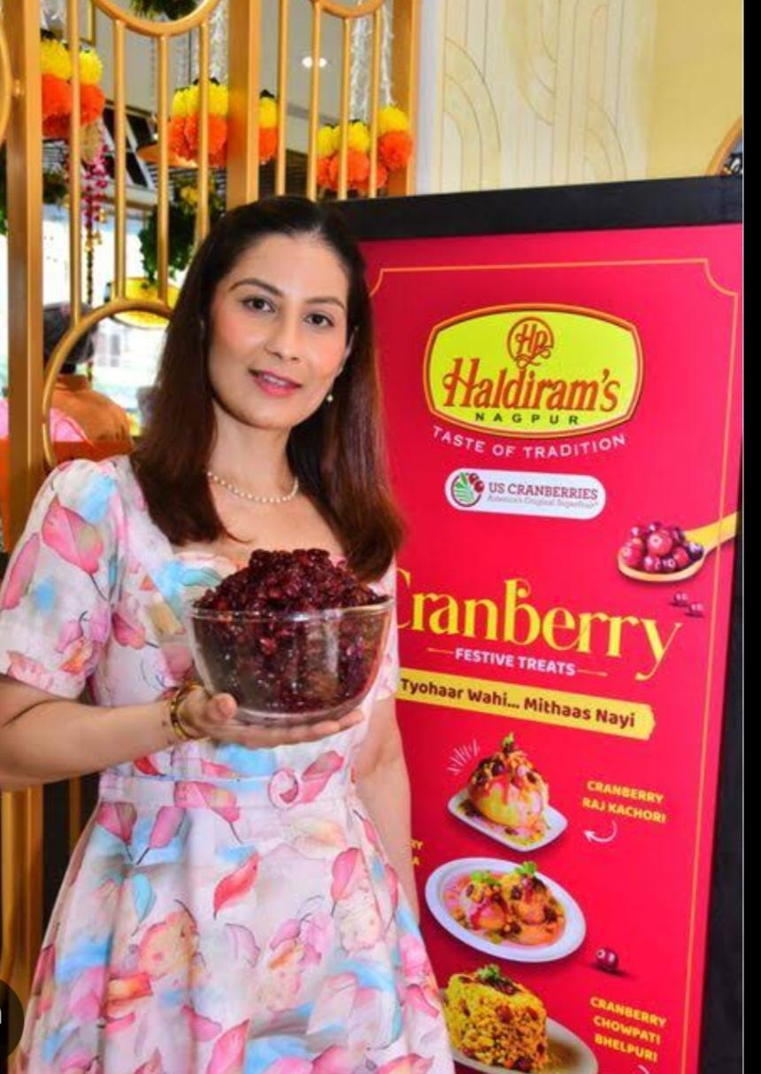

5.Customer Feedback: Encourage customers to provide feedback, suggestions, and ideas for new content.

Content channels

1.Haldiram Website: Showcase curated content on Haldiram's website, including recipes, product information, and company news.

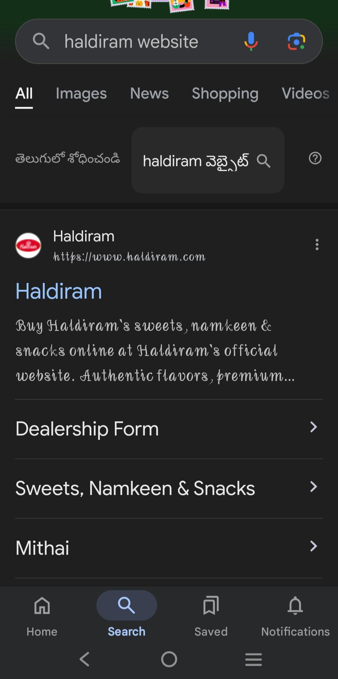

2.Social Media : Share curated content on Haldiram's social media channels, including Instagram, Facebook, Twitter, and YouTube.

3.Email newsletter: Create a monthly or quarterly email newsletter that showcases curated content, promotions, and company news.

4. Blog : Establish a Haldiram blog that features curated content, recipes, and stories behind Indian cuisine.

5.You Tube: Create a Haldiram YouTube channel that showcases recipe videos, product reviews, and company stories.

Content calendar

1.Monthly Themes : Plan monthly themes, such as "Summer Snacking" or "Diwali Recipes."

2. Weekly content : Schedule weekly content, including recipes, product showcases, and lifestyle tips.

3.Daily social media posts: Plan daily social media posts that showcase curated content, promotions, and company news.

Content Metrics

1.website Traffic: Monitor website traffic, engagement metrics, and conversion rates.

2.social media engagement:

Track social media engagement metrics, including likes, shares, comments, and followers.

3.Email Newsletter open Rates: Monitor email newsletter open rates, click-through rates, and conversion rates.

Bye implementing this content curation strategy, Haldiram can :

1. Enhance its online presence and visibility.

2. Showcase its products and expertise in Indian cuisine.

3. Engage with customers and encourage user-generated content.

4. Drive website traffic, sales, and conversions.



I would like to express my sincere gratitude for the opportunity to work on the digital marketing project for Haldiram. Your guidance and support throughout the project were invaluable, and I appreciate the trust you placed in me.

Thank you for helping me develop my skills in digital marketing and for providing me with a platform to showcase my work.

Thankyou 🥰

Presented by

Shaik Zeba Ruhi

[shaikruhishaikruhi77@gmail.com](mailto:shaikruhishaikruhi77@gmail.com)

Hall ticket:- 22358014016

Vasavi Mahila Kalasala